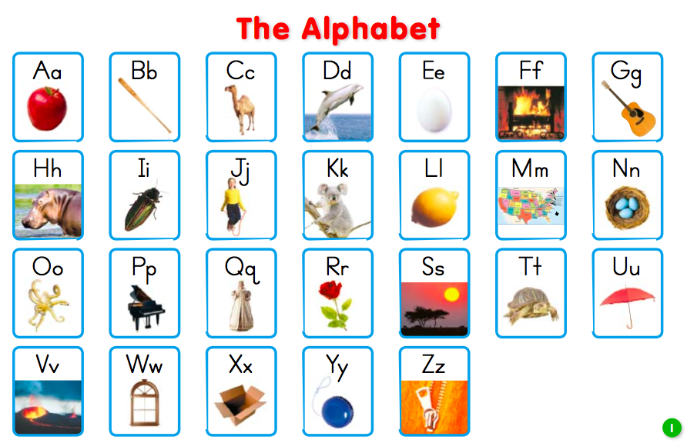

High Frequency Words to Know by the end of Kindergarten

the | to | and | a | I | see | it | my | like
for | up | look | is | go | we | little | here | can
you | this | said | in | me | big | come | blue | red
where | jump | away | down | help | make | yellow | two | play
run | find | three | funny | he | was | that | she | on
they | but | at | with | all | there | out | be | have
am | do | did | what | so | get | one | not | will
yes | went | are | now | no | came | ride | into | good
want | too | pretty | four | saw | well | ran | brown | eat
who | new | must | black | white | soon | our | ate | say
under | please | of | his | had | him | her | some | as
then | could | when | were | them | ask | an | over | just

High Frequency Words to Know by the end of Kindergarten

the | to | and | a | I | see | it | my | like
for | up | look | is | go | we | little | here | can
you | this | said | in | me | big | come | blue | red
where | jump | away | down | help | make | yellow | two | play
run | find | three | funny | he | was | that | she | on
they | but | at | with | all | there | out | be | have
am | do | did | what | so | get | one | not | will
yes | went | are | now | no | came | ride | into | good
want | too | pretty | four | saw | well | ran | brown | eat
who | new | must | black | white | soon | our | ate | say
under | please | of | his | had | him | her | some | as
then | could | when | were | them | ask | an | over | just

